# Assignment No: 9

# Arguments required to connect

You need to know the following detail of the MySQL server to perform the connection from Python.

|  |  |
| --- | --- |
| **Argument** | **Description** |
| Username | The username that you use to work with MySQL Server. The default username for the MySQL database is a **root**. |
| Password | Password is given by the user at the time of installing the MySQL server. If you are using root then you won’t need the password. |
| Host name | The server name or Ip address on which MySQL is running. if you are running on localhost, then you can use **localhost** or its IP 127.0.0.0 |
| Database name | The name of the database to which you want to connect and perform the operations. |

How to Connect to MySQL Database in Python

# Install MySQL connector module

Use the pip command to [install MySQL connector Python](https://pynative.com/install-mysql-connector-python/). pip install mysql-connector-python

# Import MySQL connector module

Import using a import mysql.connector statement so you can use this module’s methods to communicate with the MySQL database.

# Use the connect() method

Use the connect() method of the MySQL Connector class with the required arguments to connect MySQL. It would return a MySQLConnection object if the connection established successfully

# Use the cursor() method

Use the cursor() method of a MySQLConnection object to create a cursor object to perform various SQL operations.

# Use the execute() method

The execute() methods run the SQL query and return the result.

# Extract result using [fetchall()](https://pynative.com/python-cursor-fetchall-fetchmany-fetchone-to-read-rows-from-table/)

Use cursor.fetchall() or fetchone() or fetchmany() to read query result.

# Close cursor and connection objects

use cursor.clsoe() and connection.clsoe() method to close open connections after your work completes

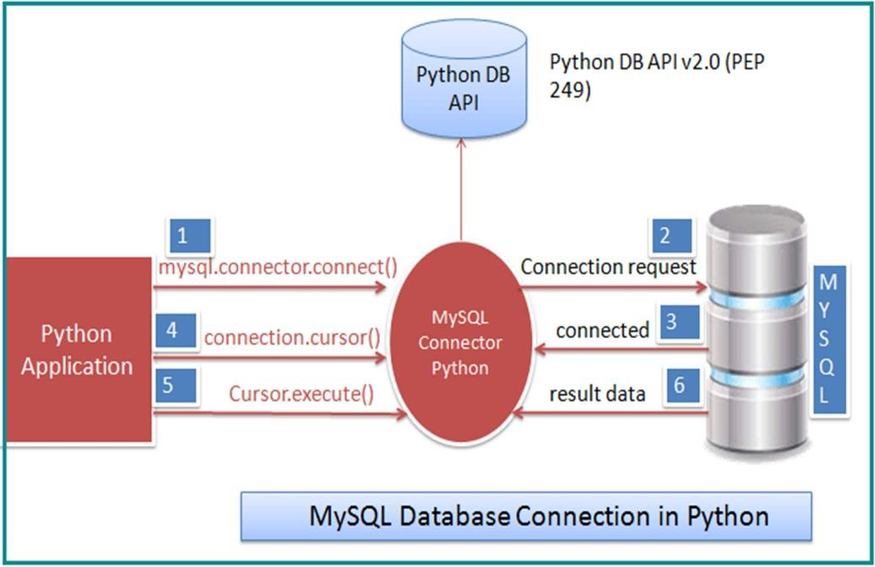

Figure 1: MySQL database connection in Python

**Connect to MySQL Database in Python**

# Assignment No 9 : Solution

**Code :**

pip install mysql-connector-python

import mysql.connector

from mysql.connector import Error

try:

connection = mysql.connector.connect(host='localhost',database='library_system',user='root',password='root')

if connection.is_connected():

db_Info = connection.get_server_info()

print("Connected to MySQL Server version ", db_Info)

cursor = connection.cursor()

cursor.execute("select database();")

record = cursor.fetchone()

print("You're connected to database: ", record)

cursor.execute("select * from library;")

record = cursor.fetchall()

print("Details of library table are: ")

print("b_id | title | author | edition | noc")

for x in record:

print(x)

f = True

while(f == True):

print("\n1.Add\n2.Update\n3.Delete\n4.display\n")

choice = int(input("Enter your choice: "))

if choice == 1:

print("\nEnter b_id | title | author | edition | noc")

b_id = int(input("Enter b_id "))

title = input("Enter title ")

author = input("Enter author ")

edition = int(input("Enter edition "))

noc = int(input("Enter noc "))

sql = "INSERT INTO library (b_id,title,author,edition,noc) VALUES (%s, %s,%s,%s,%s)"

val = (b_id,title,author,edition,noc)

cursor.execute(sql,val)

connection.commit()

print("Insert Successful!!")

print(cursor.rowcount, "record(s) inserted!")

elif choice == 2:

title = input("Enter title of the book ...")

noc = int(input("Enter noc "))

val=(noc,title)

sql = "UPDATE library SET noc = %s WHERE title = %s"

cursor.execute(sql,val)

connection.commit()

print("Update Successful!!")

print(cursor.rowcount, "record(s) affected")

elif choice == 3:

b_id = int(input("Enter ID of the book to be deleted..."))

sql = "DELETE FROM library WHERE b_id = %s"

val = (b_id,)

cursor.execute(sql,val)

connection.commit()

print("Delete Successful!!")

print(cursor.rowcount, "record(s) deleted!")

elif choice == 4:

cursor.execute("select * from library;")

record = cursor.fetchall()

print("Details of library table are: ")

print("b_id | title | author | edition | noc")

for x in record:

print(x)

ch =input("\n Do you want to continue?? (Y / N)")

if ch != 'Y':

f = False

except Error as e:

print("Error while connecting to MySQL", e)

finally:

if connection.is_connected():

cursor.close()

connection.close()

print("MySQL connection is closed")

**Output :**

Connected to MySQL Server version 8.0.30

You're connected to database: ('library_system',)

Details of library table are:

b_id | title | author | edition | noc

(1, 'TOC', 'Auth1', 2, 5)

(2, 'DBMS', 'Auth2', 3, 10)

(3, 'CN', 'Auth3', 5, 8)

(4, 'SPOS', 'Auth4', 5, 8)

(5, 'IOT', 'Auth5', 1, 4)

(6, 'DS', 'Auth6', 8, 35)

1.Add

2.Update

3.Delete

4.display

Enter your choice: 1

Enter b_id | title | author | edition | noc

Enter b_id 7

Enter title ML

Enter author Auth7

Enter edition 10

Enter noc 25

Insert Successful!!

1 record(s) inserted!

Do you want to continue?? (Y / N)Y

1.Add

2.Update

3.Delete

4.display

Enter your choice: 4

Details of library table are:

b_id | title | author | edition | noc

(1, 'TOC', 'Auth1', 2, 5)

(2, 'DBMS', 'Auth2', 3, 10)

(3, 'CN', 'Auth3', 5, 8)

(4, 'SPOS', 'Auth4', 5, 8)

(5, 'IOT', 'Auth5', 1, 4)

(6, 'DS', 'Auth6', 8, 35)

(7, 'ML', 'Auth7', 10, 25)

Do you want to continue?? (Y / N)Y

1.Add

2.Update

3.Delete

4.display

Enter your choice: 2

Enter title of the book ...ML

Enter noc 40

Update Successful!!

1 record(s) affected

Do you want to continue?? (Y / N)Y

1.Add

2.Update

3.Delete

4.display

Enter your choice: 4

Details of library table are:

b_id | title | author | edition | noc

(1, 'TOC', 'Auth1', 2, 5)

(2, 'DBMS', 'Auth2', 3, 10)

(3, 'CN', 'Auth3', 5, 8)

(4, 'SPOS', 'Auth4', 5, 8)

(5, 'IOT', 'Auth5', 1, 4)

(6, 'DS', 'Auth6', 8, 35)

(7, 'ML', 'Auth7', 10, 40)

Do you want to continue?? (Y / N)Y

1.Add

2.Update

3.Delete

4.display

Enter your choice: 3

Enter ID of the book to be deleted...6

Delete Successful!!

1 record(s) deleted!

Do you want to continue?? (Y / N)Y

1.Add

2.Update

3.Delete

4.display

Enter your choice: 4

Details of library table are:

b_id | title | author | edition | noc

(1, 'TOC', 'Auth1', 2, 5)

(2, 'DBMS', 'Auth2', 3, 10)

(3, 'CN', 'Auth3', 5, 8)

(4, 'SPOS', 'Auth4', 5, 8)

(5, 'IOT', 'Auth5', 1, 4)

(7, 'ML', 'Auth7', 10, 40)

Do you want to continue?? (Y / N)N

MySQL connection is closed

**Conclusion :**

In this assignment we have studied about database connectivity and successfully connected MySQL database with Python application.